Crop Classification and Clustering System

Project Id: AIML-4

Name :Atharv Rawat (Team Leader)
Class Roll Number: 40
University Roll Number :2028679
Section and Group: K - G1

Name : Kashish Rajput
Class Roll Number:15
University Roll Number : 2028444
Section and Group:K-G1

Name : Dhananjay Sharma
Class Roll Number:11
University Roll Number : 2028412
Section and Group: K-G1

TABLE OF CONTENTS

- Problem Description 3
- Architecture 4
- Models model 5
- Evaluation metrics used 7
- Preliminary Results and Visualizations 9
- References 12

- Problem Description
Agriculture is one of the most important sectors of the Indian economy, and efficient crop planning plays a crucial role in maximizing productivity and ensuring food security. Large agricultural datasets contain valuable information such as cultivated area, production, rainfall, and yield, but extracting meaningful insights from this data manually is difficult and time-consuming.
The objective of this project is to analyze agricultural data and automatically group records with similar characteristics using unsupervised machine learning techniques. Instead of relying on predefined labels, the system identifies hidden patterns in the dataset and classifies agricultural records into distinct clusters based on their similarities.
The project begins with data preprocessing, which includes removing irrelevant columns, handling missing values, eliminating duplicate entries, and selecting the most relevant features. The cleaned data is then standardized so that all features contribute equally to the analysis. Principal Component Analysis (PCA) is used to reduce dimensionality and visualize the data in two dimensions.
Finally, the K-Means algorithm is applied to divide the dataset into groups of similar crop-production patterns. The quality of clustering is evaluated using the Elbow Method and Silhouette Score.
The resulting clusters help identify regions with similar agricultural behavior, such as high-yield zones, low-production areas, and regions with comparable cultivation patterns. These insights can support crop recommendation systems, resource allocation, policy planning, and precision agriculture.
In summary, this project demonstrates how machine learning techniques can be used to classify agricultural data, discover hidden patterns, and generate actionable insights for improving agricultural productivity and decision-making.

- Architecture

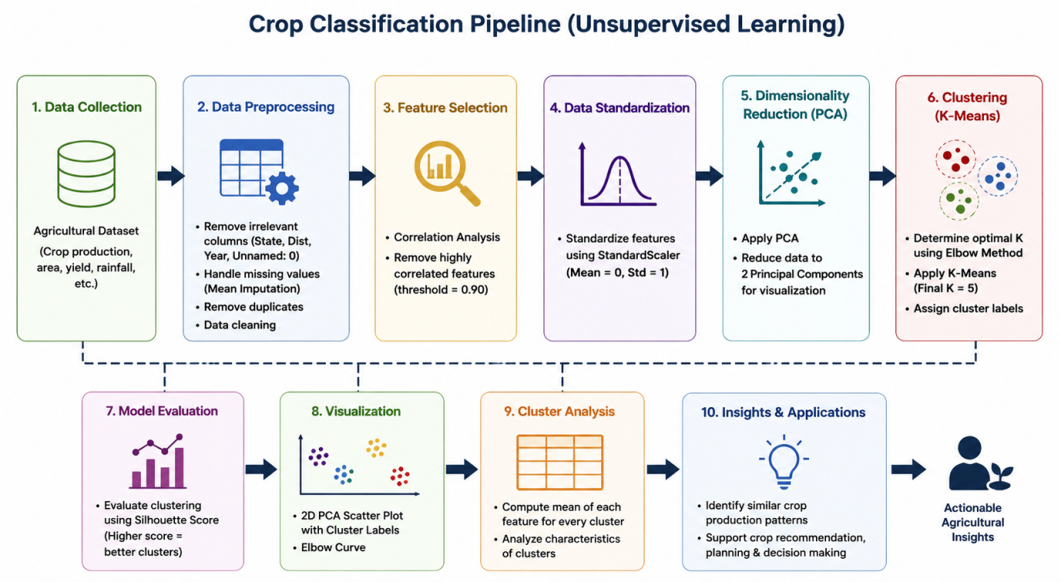

Fig. COMPLETE CLASSIFICATION PIPELINE

- Models Used(Applied/ Planned) Give a brief introduction of the models used

3.1 Models Applied in the Current Project
3.1.1 Principal Component Analysis (PCA)
Principal Component Analysis converts the original features into a smaller number of principal components while retaining most of the variance in the dataset.
In this project, PCA reduced the data to two components for visualization and noise reduction.
Advantages:

- Reduces dimensionality
- Removes noise
- Improves clustering efficiency
- Enables 2D visualization

3.1.2 K-Means Clustering
K-Means is the core algorithm used in this project.
It groups agricultural records into clusters such that records within the same cluster are similar in terms of yield, area, production, and other features.
The final model was trained using K = 5 clusters.
3.1.3Elbow Method
The Elbow Method was used to determine the optimal number of clusters by plotting Within-Cluster Sum of Squares (WCSS) against different values of K.
The “elbow point” indicated the best K value.
3.1.4 Silhouette Score
Silhouette Score measures cluster quality by comparing intra-cluster similarity with inter-cluster separation.
Range:

- +1 → Excellent clustering
- 0 → Overlapping clusters
- Negative → Poor clustering

3.2 Planned Models for Future Development
To convert the current clustering system into a fully supervised crop recommendation and prediction system, several advanced models are planned.
3.2.1 Random Forest
Random Forest is an ensemble model that combines multiple decision trees.
Each tree is trained on a random subset of the data, and the final prediction is based on majority voting (classification) or averaging (regression).
Advantages:

- High accuracy
- Handles nonlinear relationships
- Robust to noise and overfitting
- Provides feature importance

Use Case:
Predict the most suitable crop using soil, rainfall, and climate data.
3.2.2 XGBoost
XGBoost is a highly optimized gradient boosting algorithm.
It builds trees sequentially, where each new tree corrects the errors made by previous trees.
Advantages:

- Very high predictive accuracy
- Efficient and scalable
- Handles missing values

Use Case:
High-performance crop prediction and yield forecasting.
3.2.3 Support Vector Machine (SVM)
Support Vector Machine finds the optimal hyperplane that best separates classes.
By using kernel functions, SVM can model complex nonlinear relationships.
Advantages:

- Effective in high-dimensional data
- Strong theoretical foundation
- Works well with moderate-sized datasets

Use Case:
Classifying crops based on environmental conditions.
3.2.4 K-Nearest Neighbors (KNN)
K-Nearest Neighbors predicts the class of a new sample by examining the labels of the K nearest data points.
Advantages:

- Simple and intuitive
- No explicit training phase
- Effective for local pattern recognition

Use Case:
Recommend crops similar to historically successful cases.
3.3 Summary
The current project uses StandardScaler, PCA, and K-Means clustering to discover hidden patterns in agricultural data without requiring labeled crop names. Evaluation is performed using the Elbow Method and Silhouette Score.
For future development, supervised models such as Random Forest, XGBoost, SVM, KNN, and Neural Networks are planned to build a complete crop recommendation system capable of predicting the most suitable crop and expected yield with higher accuracy.

- Evaluation metrics used

Evaluation metrics are used to measure the effectiveness and quality of the machine learning models. Since the current project is based on unsupervised learning using K-Means, specialized clustering metrics were used to determine the optimal number of clusters and assess the quality of the generated clusters.
4.1 Within-Cluster Sum of Squares (WCSS)
Within-Cluster Sum of Squares (WCSS), also known as inertia, measures the total squared distance between each data point and the centroid of the cluster to which it belongs.
Formula
$$WCSS=\sum_{i=1}^{K}{\sum_{x∈C_{i}}{‖}}x−μ_{i}‖^{2}$$
Where:
K = number of clusters
$C_{i}$= set of points in the i^{th} cluster
$μ_{i}$ = centroid of the i^{th} cluster
Interpretation
- Lower WCSS indicates tighter and more compact clusters.
- WCSS always decreases as the number of clusters increases.
- It is used in the Elbow Method to choose the optimal value of K.
4.2 Elbow Method
The Elbow Method is a visual technique used to identify the optimal number of clusters.
Working Procedure
- Train K-Means for several values of K (for example, 1 to 10).
- Record the WCSS for each K.
- Plot K versus WCSS.
- Select the point where the curve bends sharply, known as the “elbow point.”
Interpretation
The elbow point represents the value of K beyond which adding more clusters produces only a small improvement.
In this project, the elbow plot indicated that K = 5 was an appropriate choice.
4.3 Silhouette Score
Silhouette Score measures how well each data point fits within its assigned cluster compared to other clusters.
Formula
$s=\frac{b−a}{\max{(}a,b)}$​
Where:
a = average distance from the point to other points in the same cluster
b = average distance from the point to points in the nearest neighboring cluster
Range and Interpretation
- +1 → Excellent clustering; points are well separated.
- 0 → Clusters overlap significantly.
- Negative values → Data points may be assigned to the wrong cluster.
A higher Silhouette Score indicates better-defined clusters.
4.4 Correlation Matrix
A correlation matrix was used during preprocessing to identify highly correlated features.
Purpose
- Detect redundant features.
- Remove features with correlation greater than 0.90.
- Improve clustering performance by reducing unnecessary information.
Interpretation
- Correlation close to +1: strong positive relationship.
- Correlation close to −1: strong negative relationship.
- Correlation near 0: little or no linear relationship.
4.5 Principal Component Analysis (PCA) Explained Variance
Principal Component Analysis provides explained variance ratios that indicate how much information each principal component retains.
Purpose
- Ensure that dimensionality reduction preserves most of the original data variance.
- Confirm that two principal components are sufficient for visualization.
Interpretation
Higher cumulative explained variance means more information is preserved after reduction.

5. Preliminary Results and Visualizations
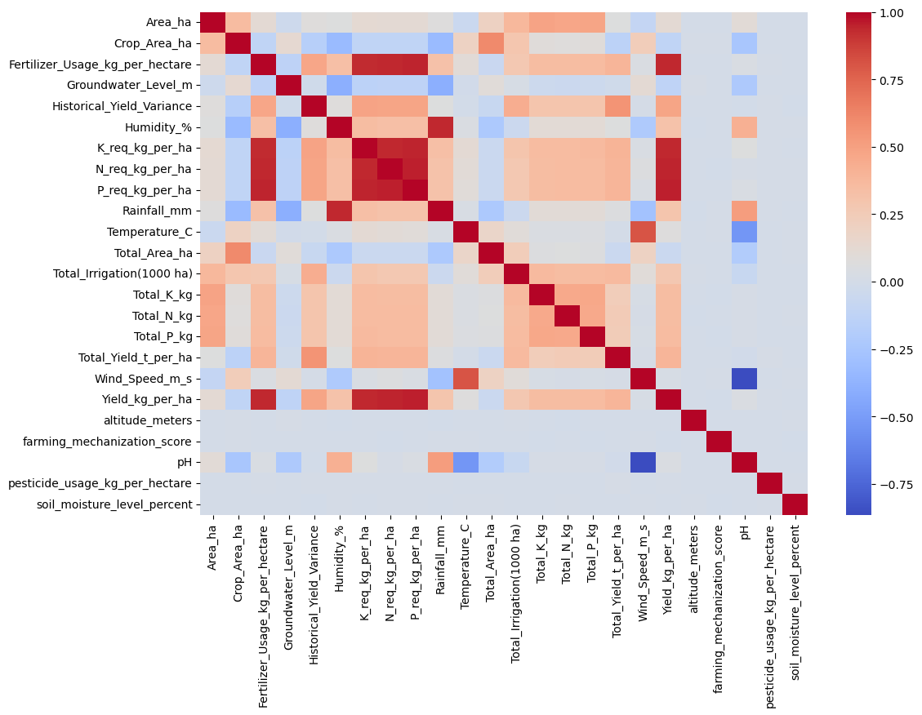

Fig.1 Heatmap showing corelation.

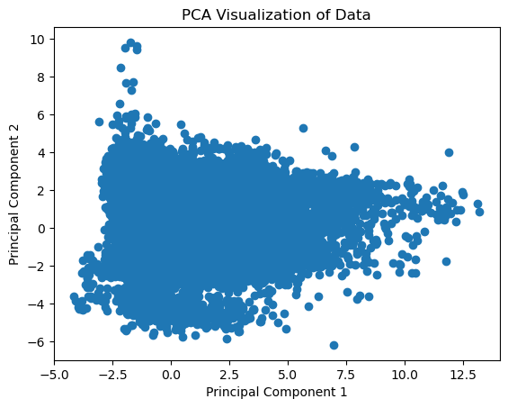
Fig.2 Principal components

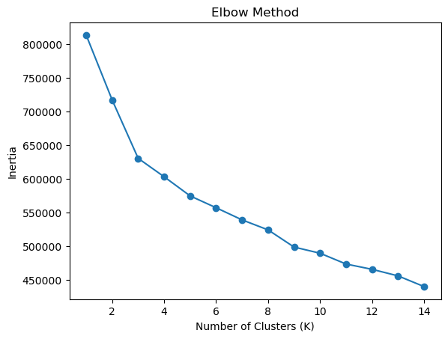 Fig.3 Elbow method graph

Area_ha Crop_Area_ha Fertilizer_Usage_kg_per_hectare \
Cluster
0 71885.905016 578061.249996 99.945507
1 47302.809981 317880.683773 72.168423
2 139022.112203 593657.332480 152.191954
3 38348.352080 550147.760899 61.035686
4 86475.350360 403684.467236 106.712182

Groundwater_Level_m Historical_Yield_Variance Humidity_% \
Cluster
0 30.693261 0.223816 68.986945
1 29.344343 0.134202 70.396330
2 29.825876 0.361278 69.873696
3 31.388239 0.121623 68.394719
4 28.986282 0.257095 70.661219

Temperature_C Total_Area_ha Total_Irrigation(1000 ha) \
Cluster
0 23.831497 9.927700e+05 16.949962
1 22.501490 4.516434e+05 5.824198
2 23.789195 1.025540e+06 32.080203
3 23.704691 9.205843e+05 6.717854
4 22.561524 6.020505e+05 13.959072

Total_K_kg Total_N_kg Total_P_kg Total_Yield_t_per_ha \
Cluster
0 3.007139e+06 3.606445e+06 1.715831e+06 1.803020
1 9.973317e+05 1.161031e+06 5.614269e+05 0.991591
2 8.396517e+06 9.407575e+06 4.575921e+06 2.683863
3 6.735240e+05 8.088805e+05 3.816286e+05 0.899746
4 3.527352e+06 4.173264e+06 1.952363e+06 1.986767

Wind_Speed_m_s altitude_meters farming_mechanization_score \
Cluster
0 2.262432 314.363399 55.045239
1 2.009005 314.926792 54.987654
2 2.246126 316.829996 54.080469
3 2.250261 316.725775 55.011884
4 2.022739 313.121089 55.134310

pH pesticide_usage_kg_per_hectare soil_moisture_level_percent
Cluster
0 6.247187 1.811548 28.086154
1 6.337598 1.800739 27.970417
2 6.257403 1.800918 27.834555
3 6.246541 1.800898 28.032921
4 6.332818 1.806735 27.978538

Fig.4 Cluster formation in K-Means

6. References:
Books
- Aurélien Géron : Hands-On Machine Learning with Scikit-Learn, Keras, and TensorFlow
- Wes McKinney : Python for Data Analysis
- Christopher Bishop : Pattern Recognition and Machine Learning
Online Resources
- GeeksforGeeks: https://www.geeksforgeeks.org/
- Stack Overflow: https://stackoverflow.com/
- Scikit-learn documentation: https://scikit-learn.org/
- Pandas documentation: https://pandas.pydata.org/
- Matplotlib documentation: https://matplotlib.org/

The above references were used for Python syntax, machine learning concepts, preprocessing methods, and plotting utilities. The dataset and crop-related assumptions were based on the ICRISAT agricultural data context and common agronomic practice.

